**Cosmetics Store Management in Salesforce**

**Introduction:**

Creating a Salesforce org is the first step toward harnessing the power of this innovative platform. Salesforce offers a transformative suite of tools designed to enhance productivity and streamline operations. This module serves as a foundational guide for users eager to explore Salesforce and utilize its capabilities to manage customer relationships effectively.

Welcome to Salesforce! This platform is equipped with a variety of features that can significantly enhance your business processes. As you progress through this module, you will discover how Salesforce can empower you to connect with customers, optimize workflows, and drive your business forward.

**Salesforce Management in Cosmetics Store:**

This document provides an overview of various Salesforce components and how they apply to Cosmetics Store Management. The components include Fields and Relationships, Page Layouts, The Lightning App, Profiles, Roles, Users, User Adoption, and Data Import.

1. **Fields and Relationships:**
2. **Page Layouts**
3. **The Lightning App**
4. **Profile**
5. **Roles**
6. **Users**
7. **Dashboards ,Reports**

**1. Fields and Relationships:**

An object relationship in Salesforce is a two-way association between two objects, which helps connect different types of data. This is crucial for Cosmetics Store Management to link related objects, such as Customers and Orders, or Consultants and Retailers.

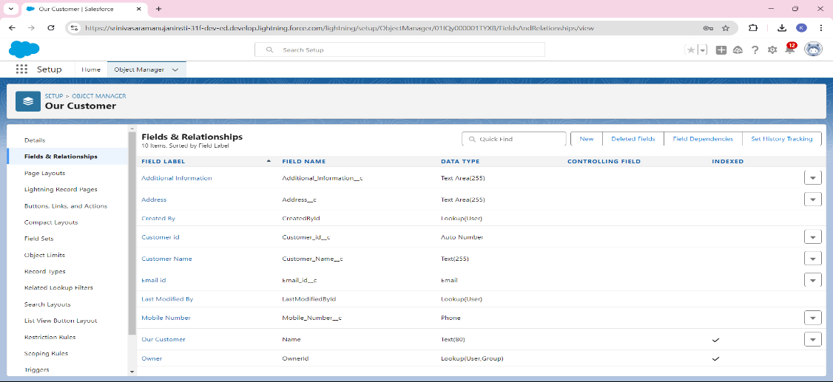

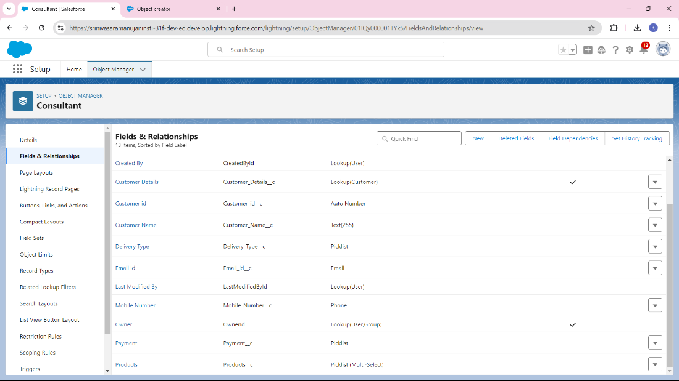

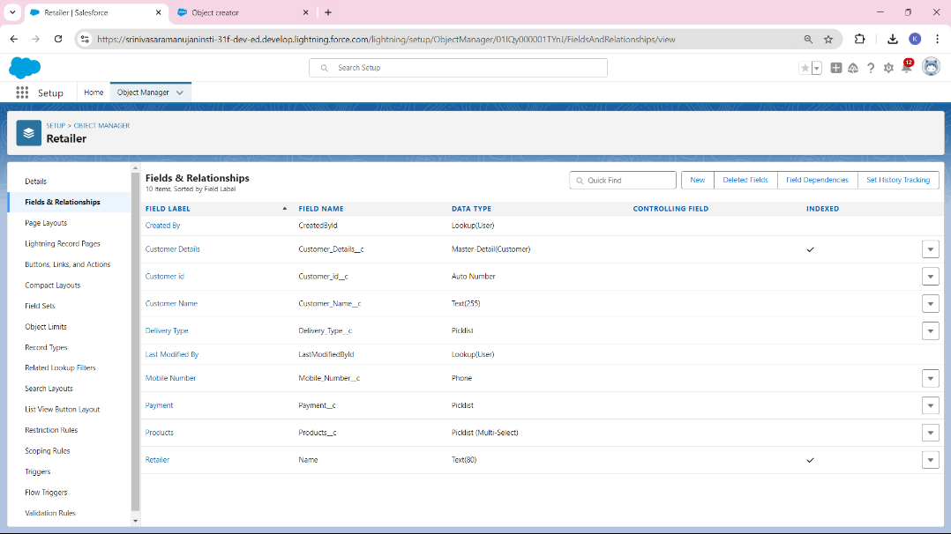

**2. Page Layouts:**

To enhance the user interface and ensure the efficient organization of consultant data, we created a customized Consultant Layout page layout. Below are the steps and the key highlights of this configuration

Steps to Create Consultant Layout Page Layout:

1. Access Object Manager:

* From the Salesforce Setup Menu, navigate to the Object Manager.
* In the Object Manager, search for and select the Consultants object.

1. Access Page Layouts:

* Once inside the Consultants object, click on Page Layouts in the left sidebar. This section displays the existing page layouts available for the Consultants object.

1. Select the Consultant Layout:
   * + - Choose the Consultant Layout from the list to begin customization.
       - This layout defines how information about consultants is displayed and managed by users.

**3.The Lightning App:**

In your Salesforce Cosmetics Management project, you created a lightning app named "Urban Colour." This app serves as a central hub for managing different functionalities related to customer relationships, sales tracking, inventory, and marketing within the cosmetics store. It provides an intuitive interface for users to access custom objects, fields, and workflows specific to cosmetics store operations, enhancing efficiency and user experience in managing day-to-day business processes

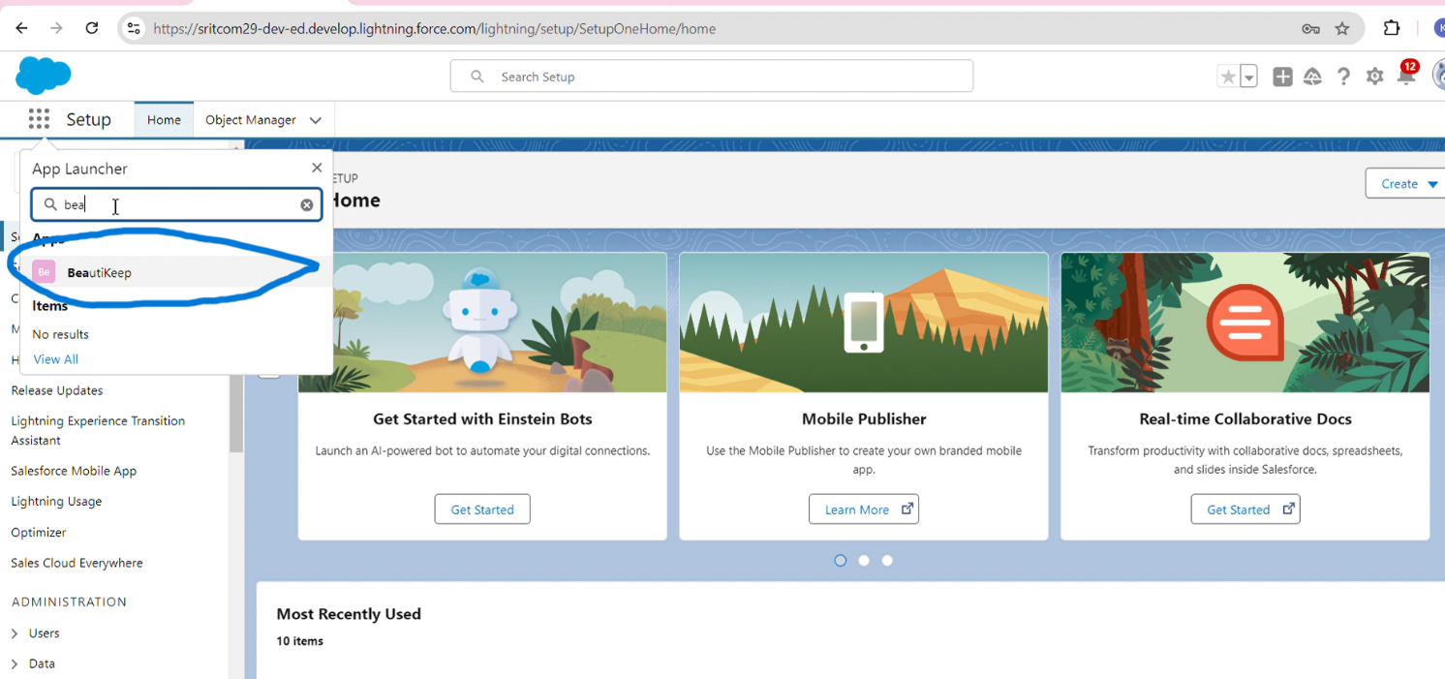

**4.Profile:**

**I**n Salesforce, profiles control access to objects, fields, and features based on the user's role. These profiles are designed for different operational tasks within the organization.

Billing Operator Profile

* Access: Limited to billing-related functions like viewing and updating customer billing data.
* Apps: Access to apps relevant to billing and payment management.
* Permissions: Can perform basic billing operations but has restricted access to other data.

Store Head Profile

* Access: Full access to store-related data, including sales, inventory, and customer information.
* Apps: Can access apps related to store management, inventory, and sales.
* Permissions: High-level access, allowing oversight and management of store operations.

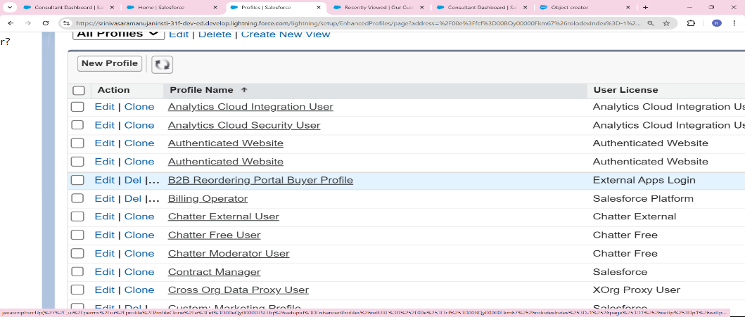

**5.Roles:**

You've created two roles: the Store Head, responsible for overseeing store operations and having access to all relevant sales and inventory data, and the Billing Operator, who manages billing processes with access limited to billing records and customer transactions. It's important to consider the hierarchy between these roles, as the Store Head might need broader access than the Billing Operator. Assigning users to these roles enforces the intended data access controls, ensuring each role can only view the information pertinent to their responsibilities.

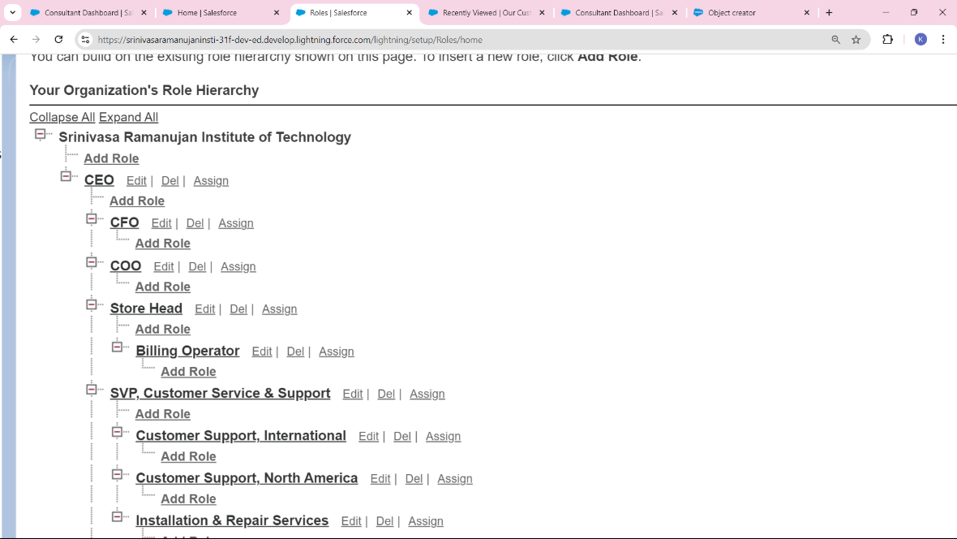

**6.Users:**

You are creating two users: Amar K, who will serve as the Store Head, and John Teddy, designated as the Billing Operator. Amar K will have access to comprehensive store operations data, allowing him to oversee sales and inventory effectively. In contrast, John Teddy's role as the Billing Operator will restrict his access to billing-related records and customer transactions, ensuring he can manage billing processes without seeing unnecessary operational data. Properly setting up these users will help maintain data security and ensure that each individual can perform their responsibilities efficiently within the Salesforce environment.

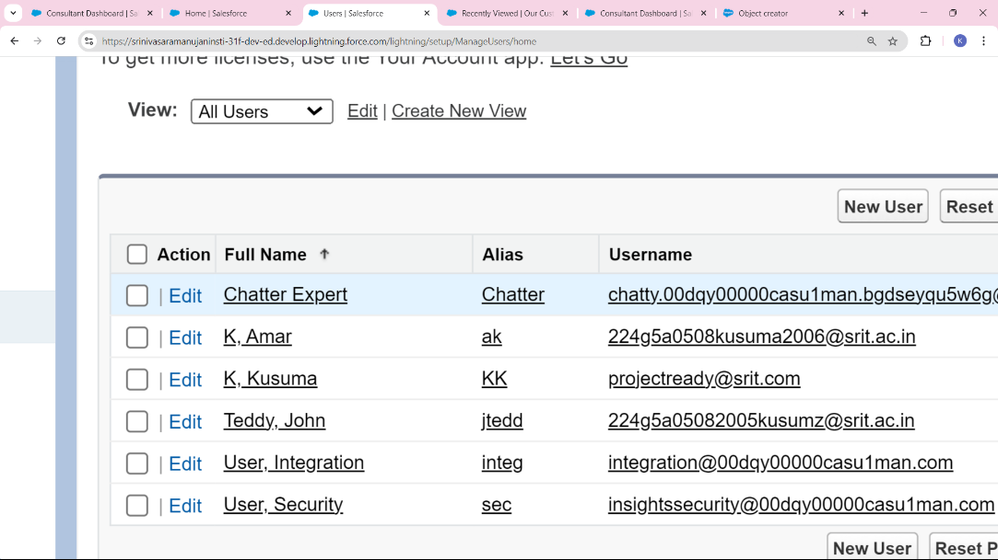



**7.Dashboards, Reports:**

In the Salesforce Cosmetics Management project, you have created a dashboard named "Consultant", alongside a report that shares the same name. This dashboard serves as a visual representation of key metrics and insights relevant to the project, allowing users to quickly assess performance and make informed decisions. The corresponding report provides detailed data that feeds into the dashboard, ensuring that the visualizations reflect the latest information. By aligning the dashboard and report under the same name, you enhance clarity and streamline access, making it easier for team members to navigate and utilize the resources effectively for managing cosmetic sales and operations.

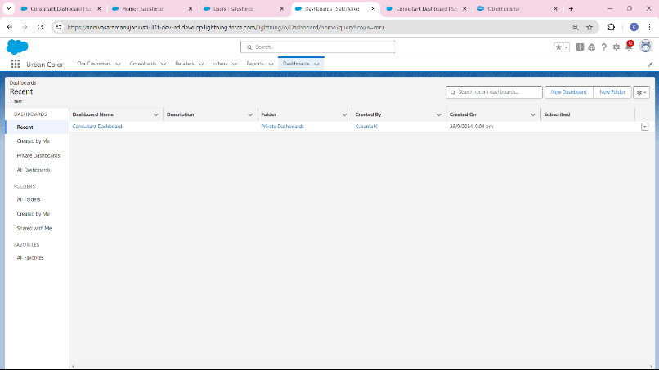

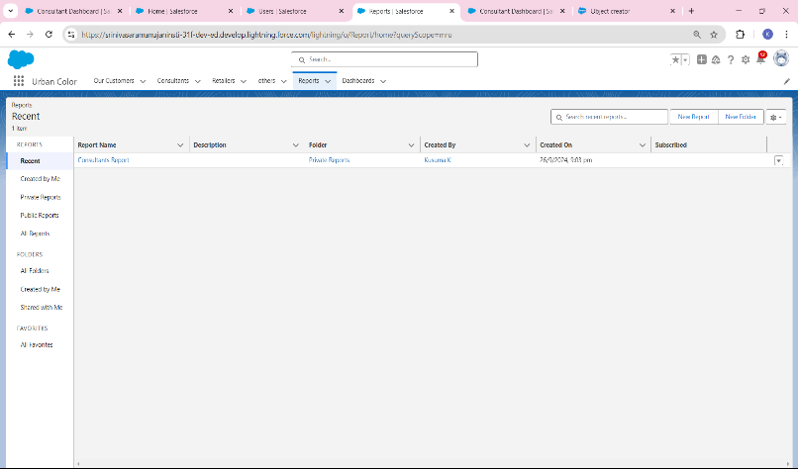

**Conclusion:**

In conclusion, the creation of the "Consultant" dashboard and its corresponding report within the Salesforce Cosmetics Management project signifies a strategic approach to data visualization and analysis. This setup not only facilitates real-time insights into key performance metrics but also enhances decision-making processes by providing a cohesive view of data. By integrating the dashboard and report, team members can easily access vital information, fostering collaboration and ensuring that all stakeholders are aligned in their efforts to optimize sales and operational efficiency within the cosmetics sector. Overall, this initiative underscores the importance of effective data management and the role of Salesforce in streamlining business operations.